CHAPTER 8: Forces, energy and motion
Worksheet 8.7

Newton’s Third Law
Student: Class:
1. State Newton’s Third Law of Motion.

2. The following diagram shows a balloon rocket built by students to investigate motion. The balloon is mounted on a horizontal string using a length of drinking straw and masking tape.
 | 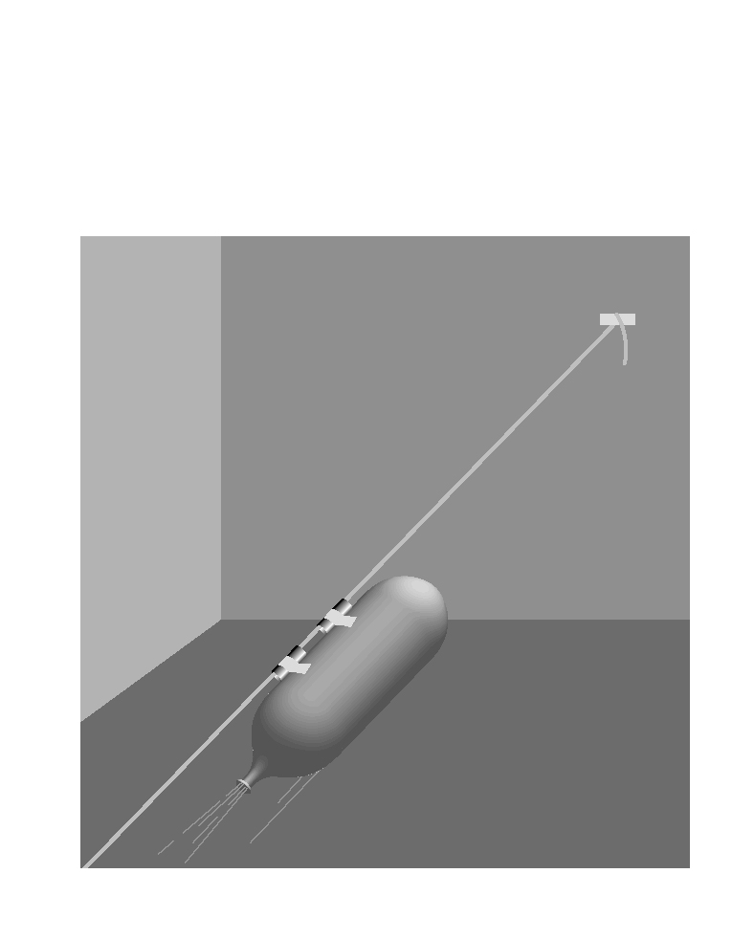 | The inflated balloon is then released.  (a) Where along the string will the balloon be moving at the greatest speed?  (b) Use Newton’s Third Law to explain why the balloon is propelled forward along the string.
3. The photograph below shows a person pushing against a wall.
Photo: Wavebreak Media Ltd / 123RF |  | The man is not moving even though he is pushing forward against the wall.  (a) What is the net force acting on the man?  (b) If the man pushes with a force of 200 N on the wall, what is the force that the wall exerts back on him?  (c) The man is pushing back on the floor with his feet with a force 200 N. With what force does the floor push back on the man?
(d) Explain what would happen if he tried to do this on a very slippery floor.

